User Engagement Monitor - new DSS custom tool
SCOPED APPLICATION INSTALLATION AND CONFIGURATION GUIDE

1. User Engagement Monitor - Configuration Guide
The User Engagement Monitor is a DSS custom solution developed on ServiceNow instance to track user login activity and support daily operational oversight. The application monitors login and logout patterns of users and highlights deviations from expected working hours. By identifying late logins and early logouts, it enables managers and administrators to understand user engagement trends and promote accountability.
With the addition of Idle Time Tracking, the solution now also measures how effectively users engage with ServiceNow during their logged-in sessions, providing deeper productivity insights.

2. Key Features of the User Engagement Monitor

2.1 Shift Adherence Tracking
- Detects when users log in after the expected start of the shift (e.g., after 09:30).
- Flags users who log out before the designated end of the shift (e.g., before 18:00).

2.2 Daily Session Records
- Stores login and logout times per session along with total session duration.
- Summarizes activity per user per session for audit and reporting purposes.

2.3 Idle Time Tracking
The app analyzes user activity inside ServiceNow to detect periods of inactivity within a session.
- Detects and calculates idle time based on gaps between meaningful user actions.
- Idle time is subtracted from session duration to estimate active working time.
- Allows administrators to identify extended periods where users were logged in but not working.
- Idle time is stored in the same activity summary record, enhancing reporting and accuracy.

2.4 Group-Based Filtering
- Tracks only the users who belong to a specific admin-defined group (e.g., User Engagement Monitor - users).

2.5 Configurable Working Hours
- Administrators can adjust start time, end time, and late login threshold via system properties - no script changes required.

2.6 Dashboard and Reporting
- A dedicated dashboard provides visual insights into late logins, early logouts, session durations, and now idle time.
- Predefined reports support quick review of user engagement patterns.

2.7 Data Retention Management
- Automatically deletes old records beyond a configurable retention period (e.g., 3 months).
- Sends optional notifications to administrators prior to data cleanup.
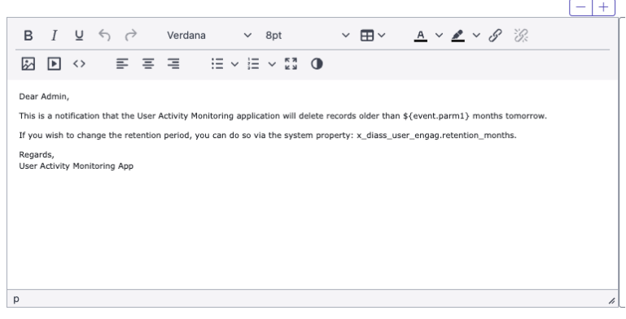

3. How It Works
The User Engagement Monitor enables automated daily tracking of user login activity and engagement patterns, helping organizations maintain visibility into attendance and productivity within the ServiceNow platform.

3.1 Configuration Setup
An administrator configures:
- Daily scheduled job to capture user session data
- Shift hours (start, end, late login threshold) via system properties
- The monitored user group (e.g., User Engagement Monitor - users)
All setup is done through configuration - no manual script editing is required.

3.2 Monitoring Execution
The first scheduled job runs every day and reviews user session data from the sys_user_session table.
This process:
- Identifies each user’s first login
- Compares it to configured shift times
- Detects late logins and early logouts
- Saves a record into a custom summary table for further reporting
This summary table is the foundation for dashboards and analytics.

3.3 Idle Time Calculation
A second scheduled job analyzes system logs (syslog_transaction) for each recorded session.
It identifies:
- Gaps between user actions (list views, form loads, searches, etc.)
- Periods longer than the configured idle threshold (default 10 minutes)
Idle time is:
- Calculated per session
- Stored in the activity summary table
- Used as part of dashboard visualizations (active time vs idle time)

3.4 Data Aggregation and Reporting
All recorded session data contributes to:
- Dashboards
- Predefined reports
- Compliance and attendance tracking
- Productivity analysis
Administrators and managers get clear visualizations of:
- Late arrivals
- Early departures
- Total working time
- Total idle time
- Active vs. inactive patterns

3.5 Data Cleanup
A separate cleanup process can automatically remove records older than a defined retention period (default 3 months).

4. Initial Configuration Setup

4.1 Request a new ServiceNow Instance or use an existing one

4.2 Import the Update Set
- Go to System Update Sets > Retrieved Update Sets.
- Click Import Update Set from XML.
- Upload the combined update set file for User Engagement Monitor.
- After import, open the retrieved update set record.
- Click Preview Update Set to check for errors or conflicts.
- If everything looks good, click Commit Update Set to apply all components (tables, Script Includes, Scheduled Jobs, Dashboards, Properties, etc.).

4.3 Set correct Time Zone for your instance
- Go to System Properties > Basic Configuration.
- Change “System timezone for all users unless overridden in the user’s record” to your actual time zone.

4.4 Initial Properties Configuration
Navigate to:
User Engagement Monitor → Initial Configuration
These properties allow administrators to adjust key settings without modifying scripts.

Time when shift is starting
- Purpose: Defines the official start time of the workday.
- Used to determine early/late login.
- Default: 09:00:00

Time when shift ends
- Purpose: Defines when the workday ends.
- Used to determine early logout.
- Default: 18:00:00

After this time we consider that login is late
- Purpose: Threshold for marking a login as late.
- Used only for first login of the day.
- Default: 09:30:00

Number of months to retain user activity records
- Purpose: Controls how long session data is stored.
- Used by scheduled cleanup.
- Default: 3 months
  - How many idle minutes must be exceeded before marking idle_warning = true
- Purpose: Defines how much time user can spend on idle time before warning is set to true.
- Used by Idle Scheduled Script
- Default: 60

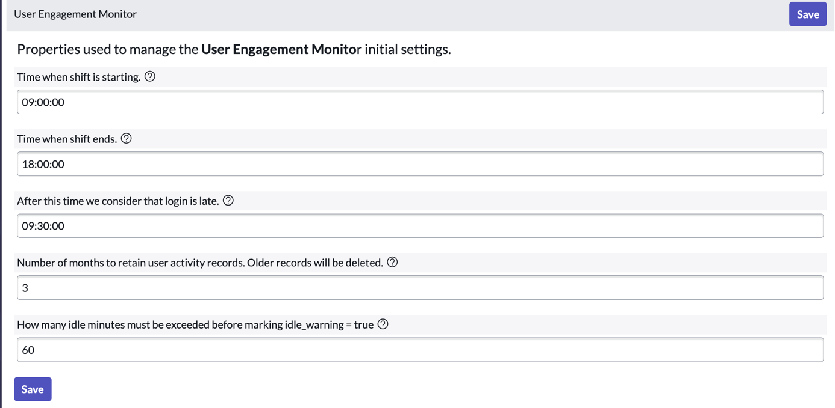

5. User Groups
Navigate to:
User Engagement Monitor → User Groups
The application comes with two predefined groups:
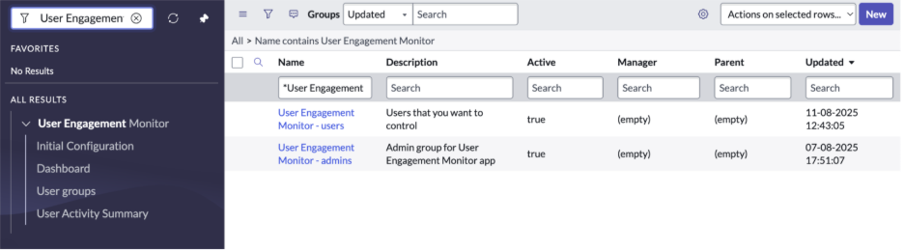

5.1 User Engagement Monitor - users
- Contains users that will be monitored.
- Only sessions of users in this group are recorded.
- Administrators can update membership at any time.
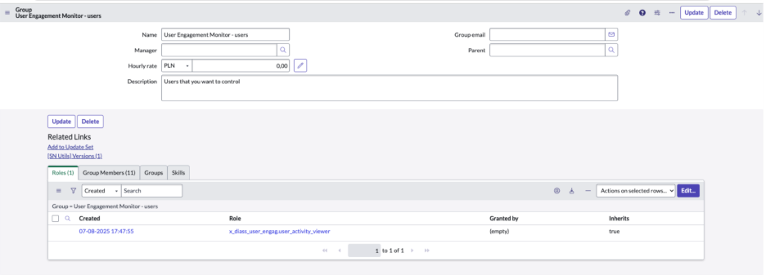

5.2 User Engagement Monitor - admins
- Contains application administrators.
- Members can view dashboards, reports, and manage settings.
- Provides full access to activity data.
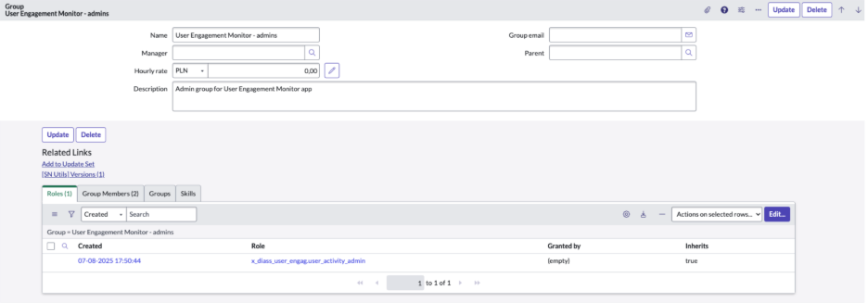

6. Scheduled Jobs Setup

6.1 User Activity Summary
Navigate to:
Scheduled Jobs → User Activity Summary
This job:
- Reads sys_user_session data
- Determines late logins / early logouts
- Saves summary records
Configure:
  - Frequency (Run field) → daily
  - Time Zone → your local timezone
  - Time (Start Time) → any time after the shift ends
(ensures all sessions for the day are complete)
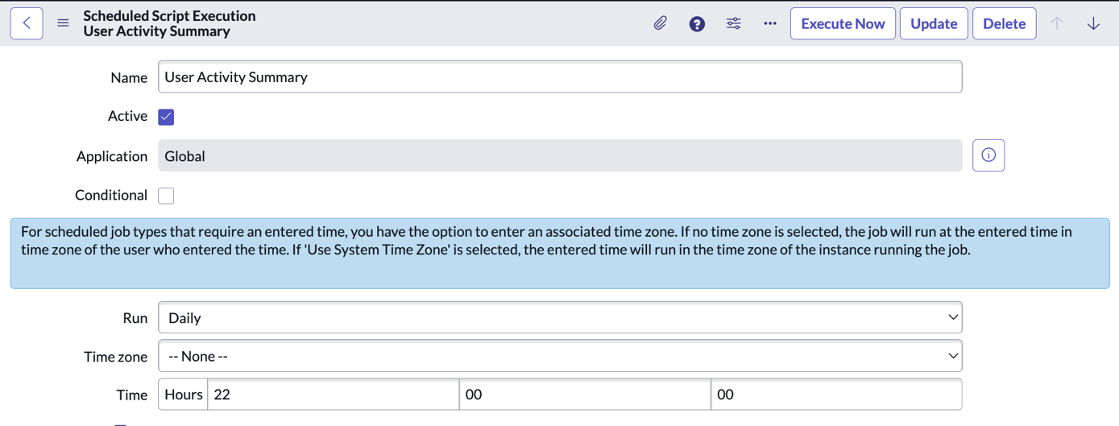

6.2 Idle Time
Navigate to:
Scheduled Jobs → Idle Time
This job:
- Reads the summary records created by the first job
- Analyzes syslog_transaction entries for each session
- Calculates idle time based on user inactivity gaps
- Updates each summary record with:
- Total idle minutes
- Idle warning flag
Configure:
- Frequency → daily
- Time Zone → same as above
- Time (Start Time) → must run after the User Activity Summary job
(recommended: run 10–15 minutes later)
This ensures idle time is calculated only for sessions that already exist in the summary table.
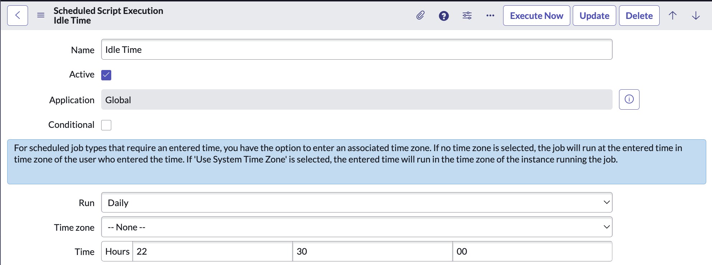

7. Testing the configuration
Objective:
Verify that the application correctly tracks user logins/logouts, idle time, applies late login and early logout rules based on configured properties, stores results in the custom table, and displays them in the dashboard.

7.1 Configure Application Properties
Navigate to User Engagement Monitor > Initial Configuration.
Set the following values (example test setup):
- Time when shift starts: 09:00:00
- Time when shift ends: 18:00:00
- After this time we consider that login is late: 09:30:00
- Number of months to retain user activity records: 3
- How many idle minutes must be exceeded before marking idle_warning = true: 60
Save the configuration.
7.2 Add Test Users to Tracking Group
- Navigate to User Engagement Monitor > User groups.
- Add your selected test users to User Engagement Monitor – users group.
7.3 Add Admin to Admin Group
- Add your test admin account to User Engagement Monitor – admins group.
- Verify that you can access all of the pages under User Engagement Monitor module.
7.4 Check time zone of your Servicenow Instance
- Go to System Properties > Basic Configuration.
- Change “System timezone for all users unless overridden in the user’s record” to your actual time zone.
7.5 Simulate User Activity
- Make sure that user has correct time zone in his user record (sys_user)
- As a tracked test user, log into the instance at different times to simulate:
  - Late login: After 09:30:00
  - Early logout: Before 18:00:00
- Ensure the test users have at least one session for today in sys_user_session.
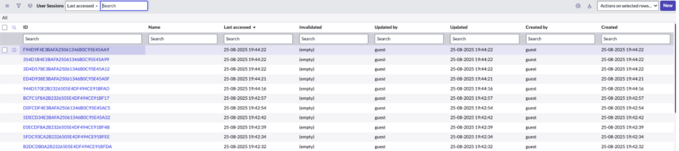

7.6 Execute Scheduled Job
- Navigate to System Definition > Scheduled Jobs.
- Locate the User Activity Summary scheduled job.
- Make sure that Time Zone is set correctly
- Click Execute Now to process today’s sessions.
7.7 Execute Second Scheduled Job
- Navigate to System Definition > Scheduled Jobs.
- Locate the Idle Time scheduled job.
- Make sure that Time Zone is set correctly.
- Click Execute Now to process today’s sessions.
7.8 Expected Data in Custom Table
- Open User Engagement Monitor > User Activity Summary.
- Verify that:
- A record is created for each tracked user session.
- Late Login is true for sessions starting after 09:30:00 – only first session of the day
- Left Early is true for last sessions ending before 18:00:00 – only last session of the day
- Login time, logout time, and session duration match simulated activity.
- Idle time showing time when user was not active – it will show only if longer than 10 minutes
7.9 Verify Dashboard Data
Note: Please notice that some reports needs data from at least couple days to show correct graphs.

- Open User Engagement Monitor > Dashboard – Shifts
- Open User Engagement Monitor > Dashboard – Idle time
- Confirm that:
- The Late Login report displays users who logged in after the configured threshold.
- The Left Early report displays users who logged out before the shift end time.
- Counts and values match the data in User Activity Summary.
- Idle time showed correctly per user
- Activity time listed correctly

